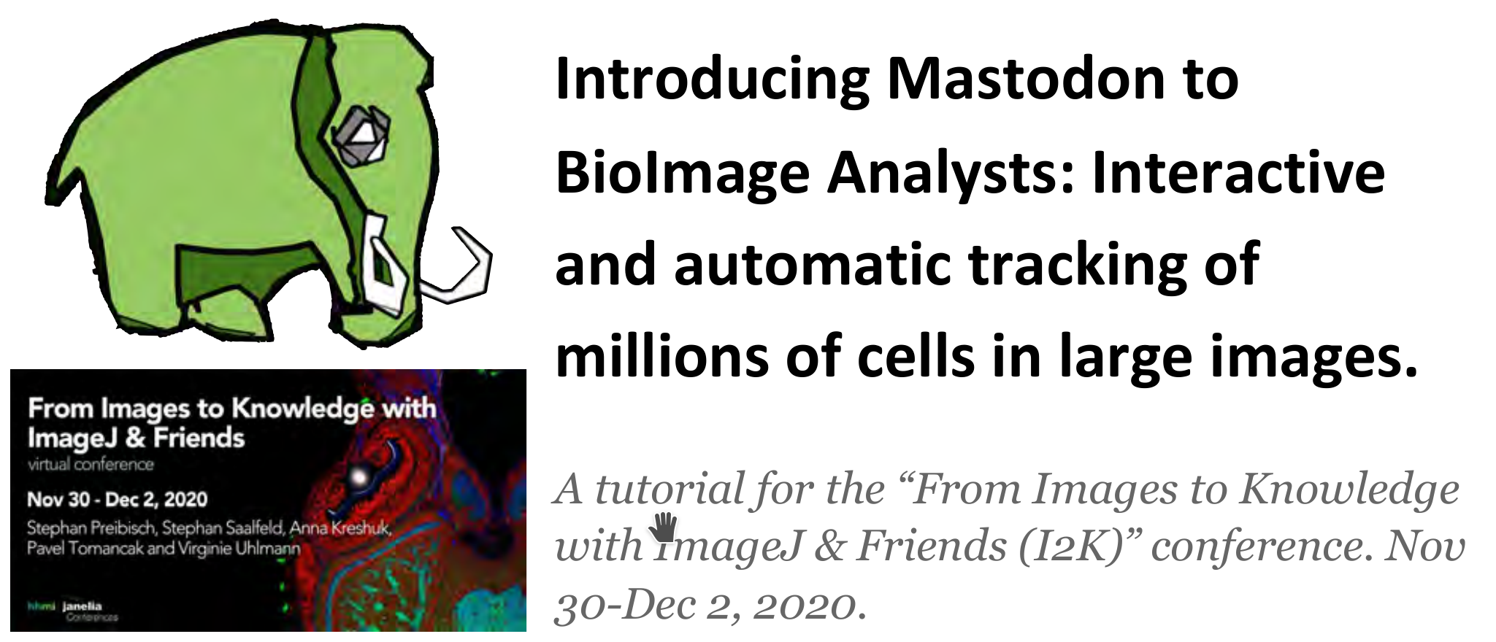

You can download a Mastodon project file for the workshop here:

>>>>>>>>>>> CTC_TRIF_trainingVideo02.mastodon <<<<<<<<<<<

This file refers to the BigDataViewer’s main entry file here:

>>>>>>>>>>> CTC_TRIF_trainingVideo02.xml <<<<<<<<<<<

The image data is a TRIF training video 02 from the CellTrackingChallenge.net.

We thank the challenge organizers for kindly agreeing to use their data.

Please note the conditions to use the images:

The use this dataset in a publication is generally possible, but only with the explicit consent given by the challenge organizers and the particular dataset provider.

The use of the dataset for other than research purposes is generally possible, but only with the explicit consent given by the challenge organizers and the particular dataset provider.

The original dataset provider is:
Dr. A. Jain. Max Planck Institute of Molecular Cell Biology and Genetics, Dresden, Germany

